Customer: | Edmonton Exchanger
Project: | ENH1638 - BTP EdEx eBalance AI/ML (Project D)
Document Purpose: | Conceptual Solution Design Document  This document defines a conceptual solution design for a rules-based validation framework in the field services industry. It introduces a rule card structure to capture and operationalize billing and payment rules from contracts, agreements, policies, and memos, enabling consistent evaluation through a Rules Knowledge Base and Rule Evaluation Engine. The design is scalable across labor, equipment, materials, and third-party charges, while Phase 1 focuses on labor hours and expenses.
Document Status: | Draft
Author: | See Revision History
Date: | See Revision History

Revision History
Date | Author | Revision Summary
Sep 10, 2025 | Chris Hogan | Initial version.
Sep 10, 2025 | Rob Patterson, Chris Hogan | Updates to Rule record design based on Rob, Chris working session.
Sep 11, 2025 | Chris Hogan | Revised Rule record design to be more clear, better filtering, detailed provenance. Reviewed with Rob.
Sep 16, 2025 | Chris Hogan | Adding FieldVu fields we Do and Don’t have today.
Sep 19, 2025 | Chris Hogan | Revised Rule record design now addresses rule dependencies, substitutions, and modifications.
Sep 20-21, 2025 | Chris Hogan | Added new sections “High-Level Conceptual Solution Overview”, “(NEW) Rule Card Structure”, “NEW) Rule Card Elements”. Updated Worked Rule Card examples section overtime meal breaks, meals, meal allowances examples to reflect revisions.
Sep 22, 2025 | Chris Hogan  Rob Patterson | Updates to Rule record design based on Rob, Chris review session.
Sep 22, 2025 | Chris Hogan | Added section “High-Level Workflow: FieldVu → Rule Validation Engine → Pass/Fail Outcomes”.
Sep 22, 2025 | Rob Patterson | Reviewed “High-Level Workflow: FieldVu → Rule Validation Engine → Pass/Fail Outcomes”. Added comments/feedback.
Sep 23, 2025 | Chris Hogan  Rob Patterson | Met with Rob, discussed comments/feedback, we’re both aligned on current conceptual design approach (sections 1-7).

Introduction
The purpose of this document is to articulate the conceptual design of a rule card structure for representing rules extracted from customer contracts, union agreements, company policies and procedures, amendments, and memos in the field services industry.
This is not a prescriptive technical solution, architecture, or system design. Instead, it is a working draft of concepts, elements, and illustrated examples that convey the shape of the rule structure. The intent is to ensure a shared understanding across stakeholders — from ML scientists to solution architects to business leaders — of how rules will be captured, organized, and expressed for downstream systems to use.
The rule card format provides a minimal but complete way to express extracted rules so they can be deterministically evaluated at runtime, applied consistently, and explained clearly.

Overarching Design Principles
The solution we are designing must address the pain points of the field services industry as a whole. While EdEx is the first customer and Phase 1 focuses on labor hours and expenses, the long-term design must be broad enough to cover equipment, materials, third-party, and other charges. EdEx themselves have confirmed they ultimately want such a solution once their process and data issues allow.
Therefore, we cannot design narrowly for EdEx’s current state, nor can we design only around today’s systems. Instead, we must design from the document rules — because those rules are what govern how field services project costs are billed to customers and paid to workers and suppliers.
The following principles guide this solution design:
- Industry-driven, not customer-limited — the design comes from the governing documents of field services (contracts, agreements, policies, memos), not from the current capabilities or constraints of EdEx, FieldVu, or any one system. This ensures the solution is relevant to the industry as a whole.
- System-aware but not system-bound — the structure must allow systems like FieldVu to look up and apply rules reliably, but it is not designed only for FieldVu. It is designed from the rules themselves, so that any system needing to query the rule set and check compliance or non-compliance can consume it in the same way.
- Simplicity — keep the design minimal, with each part serving one clear purpose. Complexity should only be added when it delivers direct value.
- Extensibility — the design must be open so it can grow naturally to handle future requirements (e.g., equipment, materials, third-party charges, other costs) without reinvention.
- YAGNI (You Aren’t Going to Need It) — avoid building elements that are not needed today. This prevents over-engineering and keeps the design focused.
- Deterministic and consistent — every line of data must be evaluated the same way every time. Rules either qualify for evaluation or they don’t; triggers always produce true or false. This consistency builds trust in both real-time validation and historical audits.
- Fast and scalable — the solution must support efficient lookups and evaluations across a single line, an entire timesheet, or historical datasets. Performance is achieved through reuse of candidate rules, grouping by shared attributes, and precomputed totals.

Scope of Rules the Solution Covers
Not all document rules are relevant to this solution. Our focus is the subset of rules that govern how project costs are billed to the customer and how workers, suppliers, and other parties are paid. Within that subset, we distinguish between labor, equipment, materials, third-party, and other charges.
Phase 1 of the solution focuses on labor hours and expenses, but the design is intentionally broad enough to handle equipment, materials, third-party, and other charges in future phases — without requiring redesign or re-ingestion of documents.
The diagram below illustrates the relationship between all document rules, the subset relating to billing and payment, and the categories within that subset. The table clarifies what is included in the overall solution design, what is in scope for Phase 1, and what is deferred to future phases.
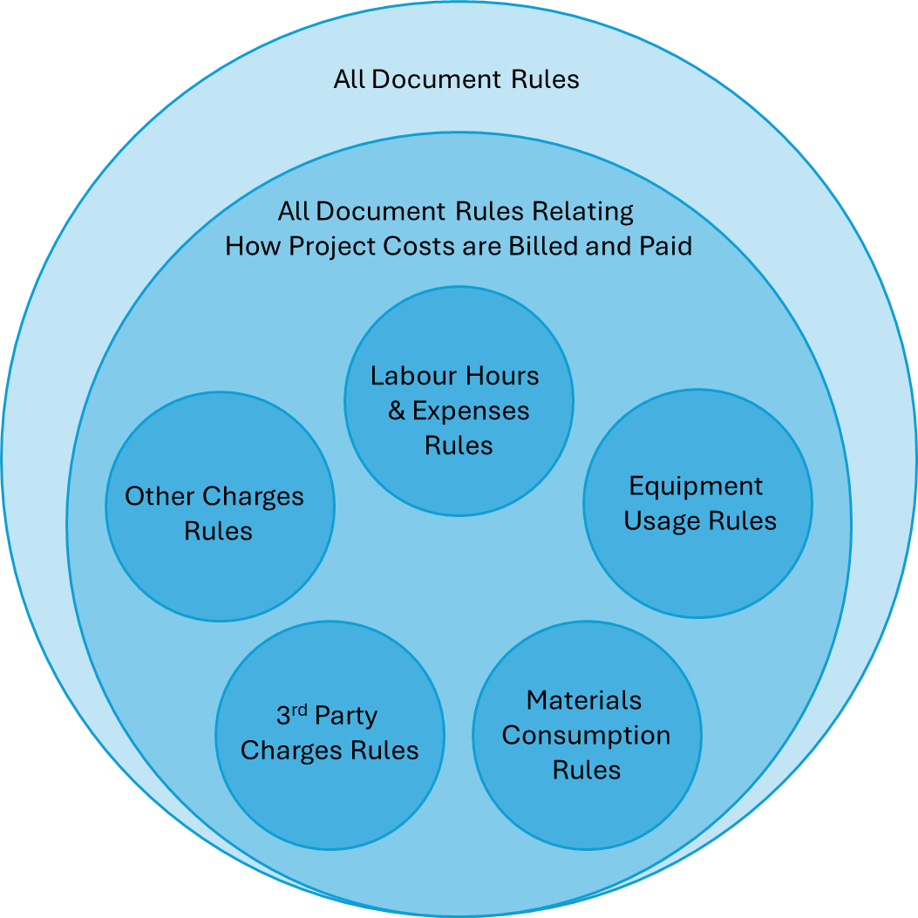

Set | Solution Design | Solution Scope Phase 1 | Solution Scope Future Phases
All Document Rules | ❌ | ❌ | ❌
All Document Rules Relating to How Project Costs are Billed and Paid | ✅ | ✅ | ✅
Labour Hours & Expenses Rules | ✅ | ✅ | ✅
Equipment Usage Rules | ✅ | – | ✅
Materials Consumption Rules | ✅ | – | ✅
3rd Party Charges Rules | ✅ | – | ✅
Other Charges Rules | ✅ | – | ✅

High-Level Conceptual Solution Overview

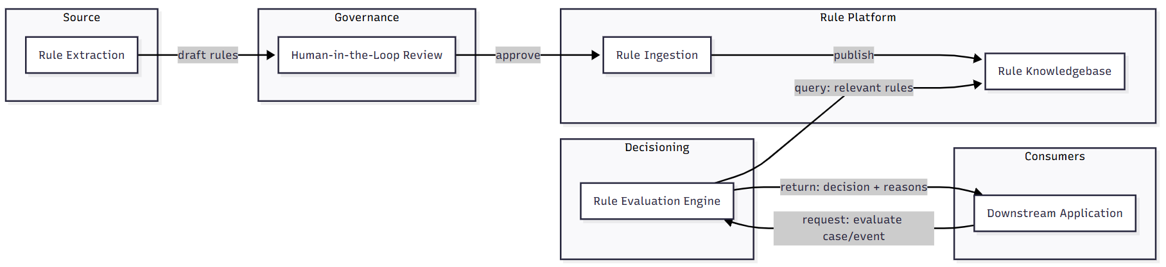

- Rule Extraction
  - Who: LLM, automation
  - What: extract rules from source document (e.g customer contracts, union agreements, amendments, policies, memos, etc) and draft them into Rule Card machine-readable format.
- Human-in-the-Loop Review
  - Who: contract subject matter expert (business user)
  - What:
    - validates machine-drafted rule cards against the source document
    - edits rule cards as needed
    - approves rule cards for ingestion into Rules Knowledge Base
- Rule Ingestion
  - Who: rule lifecycle service
  - What:
    - Makes rule card available for discovery within the Rules Knowledge Base.
    - Controls a rule’s overall lifecycle, discoverability, and use within an environment.
- Rule Knowledge Base
  - Who: rule knowledge base service
  - What: Stores rule cards so they are discoverable and usable at runtime.
- Rule Evaluation Engine
  - Who: rule evaluation service
  - What:
    - Accepts requests to verify whether a case or event complies with applicable rules.
    - Retrieves all relevant rules for the case or event.
    - Evaluates those rules and generates Obligation records for any triggered rules.
    - Processes the triggered rules further by applying defined operations (e.g., substitutions, replacements, top-ups, caps) to the Obligation records, while also handling conflicts and prioritization.
    - Compares the resulting set of Obligation records against the case/event fact data.
    - Returns a pass/fail decision indicating whether the fact data complies with the obligations, along with detailed reasons for the decision.
- Downstream Application
  - Who: e.g., FieldVu (or another app)
  - What:
    - Sends case/event to the Rule Evaluation Engine for a compliance check.
    - Receives pass/fail decision and reasons from the Rule Evaluation Engine.
    - Uses the decision (pass/fail) and reasons to warn, block, or suggest fixes to the application user.
    - Logs rule evaluation requests, results, and follow-on actions accordingly.

High-Level Workflow: FieldVu → Rule Validation Engine → Pass/Fail Outcomes

The Story
A worker has finished a long 15-hour shift, and we’ve entered their Crew Sheet (timesheet) into FieldVu. We want to ensure that:
- the hours are entered correctly,
- the expected meals and breaks were either received or compensated for, and
- everything aligns with the relevant rules.
FieldVu should check the Crew Sheet against those rules and return whether it meets them, or not, and why.

Story Setting:
- Job site is located in Alberta, Canada
- NMA-AB union agreement is applicable to this job (using just this one to keep story simple)
- Worker is a Pipefitter-Journeyman
- Worker is a unionized employee
- Worker is currently on a work schedule of 5x8 (Mon-Fri)
- Worker is currently staying in site’s Camp accommodations
- Date of field service was Wednesday, September 17, 2025
- This service was not a callout event for this worker

What Actually Happened in the Field that Day:
This pipefitter worked and received as follows:
- Hours worked: 15.0 total
- Meals received: 1 company-provided
- Meal Breaks received: 1 paid

Rule Evaluation Workflow

Timekeeper enters in FieldVu Crew Sheet
Timekeeper enters in FieldVu Crew Sheet the values as were recorded by the Foreman on the manual timesheet: (data which we don’t have field for in FieldVu today are flagged)
- Header
  - Customer = … (✅FieldVu has)
  - Site = … (️FieldVu has Location but unsure about Jurisdiction)
  - Job = … (✅FieldVu has)
  - Foreman = … (✅FieldVu has)
  - Date = 2025-09-17 (✅FieldVu has)
- Labour Lines
  - Employee Id = … (✅FieldVu has)
  - Work Type = Pipefitter, Journeyman, Unionized (✅FieldVu has)
  - ST = 9.0 hrs (✅FieldVu has)
  - OT = 3.0 hrs (✅FieldVu has)
  - DT = 2.5 hrs (✅FieldVu has)
  - Meal Break = 0.5 hrs (✅FieldVu has)
  - Meals = 1 (❌FieldVu missing)
  - Tags (❌FieldVu missing)
    - “work_schedule:5x8 Mon” (❌FieldVu missing)
    - “staying_in_site_camp:true” (❌FieldVu missing)
    - “is_callout:false” (❌FieldVu missing)

FieldVu sends rules check Request to Rule Evaluation Engine
Timekeeper clicks button to have FieldVu validate the data currently entered in the Crew Sheet.
FieldVu sends a rules check request to the Rule Evaluation Engine with just:
- the context (where/when/who surrounding field service event), and
- the facts that were recorded on the Crew Sheet that are to be checked against the rules

Request Example (Conceptual):
(FieldVu may provide more context than shown here — only a few examples are included for brevity.)
{
"context": [
{
"kind": "service_event",
"value": {
"date": "2025-09-17",
"job_id": "<JOB_GUID>",
"job_code": "<JOB_CODE>",
"job_name": "<JOB_NAME>",
"contract_name": "Contract C1000776 - Edmonton Exchanger Refinery Service Ltd/ NWR Sturgeon Refinery",
"site_id": "<SITE_GUID>",
"site_name": "Sturgeon Refinery",
"customer_id": "<CUSTOMER_GUID>",
"customer_name": "North West Redwater Partnership"
}
},
{
"kind": "involved_parties",
"value": [
{
"party_type": "employee",
"id": "<EMPLOYEE_GUID>",
"employee": {
"trade": "pipefitter",
"classification": "journeyman",
"employment_type": "union",
"work_schedule": "5x8",
"staying_in_site_camp": true,
"is_callout": false,
"is_scheduled_overtime": false
}
}
]
}
],
"facts": [
{
"fact_type": "event",
"kind": "worked_time",
"date": "2025-09-17",
"duration": "PT9H",
"rate": "straight_time"
},
{
"fact_type": "event",
"kind": "worked_time",
"date": "2025-09-17",
"duration": "PT3H",
"rate": "overtime"
},
{
"fact_type": "event",
"kind": "worked_time",
"date": "2025-09-17",
"duration": "PT2H30M",
"rate": "double_time"
},
{
"fact_type": "event",
"kind": "meal_break",
"date": "2025-09-17",
"duration": "PT30M"
},
{
"fact_type": "event",
"kind": "meal",
"date": "2025-09-17",
"quantity": 1
}
]
}

Rule Evaluation Engine grabs relevant rules from Rules Knowledge Base

This is where the Rules Evaluation Engine uses the Request.Context and the RulesKnowledgeBase.Rules.Context to fetch the rules it will need to take into consideration. It will search all rules in the knowledge base regardless of origin document source (e.g. customer contracts, union agreements, amendments, memos, etc) and return only those which are relevant to the Request.Context.

Note: The Context elements are a key part of the filtering process. They ensure that the engine returns all applicable rules, and only those rules.
Note: So far, we’ve been thinking about the rule record metadata and the request metadata from FieldVu as simple “filters”, almost like applying AND/OR conditions in a SQL query to narrow down relevant rules. But maybe a better way to think about it is this: FieldVu should pass in sufficient relevant context about the work event (who, what, where, when, etc.) that it’s wanting to validate against the rules. Then, instead of just filtering rules by exact field matches, the Rule Evaluation Engine could do a semantic search across the rules knowledge base. In practice, this means rules would be indexed by a common set of metadata properties, and the engine would use vector-style search to find all rules that are contextually similar to the request. That way, the system isn’t limited to rigid filters, but can more intelligently bring back all the relevant rules. Amii, Rob, let’s explore and discuss it further.

Since the job is in Alberta, Canada, service date is 2025, and involves unionized employees under the 2025–2028 NMA-AB union agreement, the system applies the following rules:
Included (Relevant) Rules:
- …
- ✅NMA-AB, 15.300 (a), Overtime Provisions, 5x8 Work Schedule
- …
- ✅NMA-AB, 15.600, Overtime Meal Breaks & Meals
- ✅NMA-AB, 15.602, Overtime Meal Allowance
- ✅NMA-AB, 15.604, Overtime Meal Allowance (Subsistence & Camp)
- …
Excludes (Not Relevant) Rules:
- …
- ❌NMA-AB, 15.300 (b), Overtime Provisions, 4x10 Mon-Thu Work Schedule
- ❌NMA-AB, Appendix D, Overtime Provisions, 9/80 Work Schedule
- ❌NMA-AB, 15.800, Callout Minimum
- …

Note: This storyline is intentionally simplified to show only the NMA-AB rules and only the selected examples listed above. In reality, the engine would return many more rules at this phase, but still only those that are relevant to the given Request.Context.

Rules Evaluation Engine “1st Pass” to emit rule Obligations

This is where the Rules Evaluation Engine evaluates the Trigger condition of each relevant rule. For every rule whose Trigger evaluates to true, the Engine emits the Obligations defined within that rule. These Obligations describe what must be fulfilled (e.g., paid, provided, reimbursed, or otherwise resolved) in order for the rule to be considered met.
All emitted Obligations are collected into an initial list, which serves as the baseline for subsequent Operations and Validations.

Note: This workflow does not yet show where contract or agreement priority is handled. The Rule Evaluation Engine manages that priority, making sure rules are applied in the correct order. For example, if two agreements cover the same situation, the more specific agreement takes precedence, or one agreement may explicitly defer to another. It feels like that belongs in “1st Pass”.

Obligations emitted:
- ✅NMA-AB, 15.300 (a), Overtime Provisions, 5x8 Work Schedule
  - Since:
    - DayOfWeek(Request.Context.service_event.date) = Wednesday
  - Obligations emitted:
    - worked_time, upto first 8 hours ST
    - worked_time, upto next 2 hours OT
    - worked_time, upto rest hours DT
- ✅NMA-AB, 15.600, Overtime Meal Breaks & Meals
  - Since
    - Request.Context.involved_parties[ThisEmployee].employee
      - .work_schedule = "5x8"
      - .is_callout = false
      - .is_scheduled_overtime = false
    - Sum of “worked_time” within Request.Facts > 10
  - Obligations emitted:
    - Meal #1 at 10 hrs
      - meal
      - meal_break, 0.5 hrs ST
    - Meal #2 at 14 hrs
      - meal
      - meal_break, 0.5 hrs ST
- ✅NMA-AB, 15.602, Overtime Meal Allowance
  - Since
    - It this rule itself doesn’t declare any Obligations
  - Obligations emitted:
    - None
- ✅NMA-AB, 15.604, Overtime Meal Allowance (Subsistence & Camp)
  - Since
    - It this rule itself doesn’t declare any Obligations
  - Obligations emitted:
    - None

Contents of Obligations Set after “1st Pass”:
- worked_time, upto first 8 hours ST
- worked_time, upto next 2 hours OT
- worked_time, upto rest hours DT
- meal
- meal_break, 0.5 hrs ST
- meal
- meal_break, 0.5 hrs ST

Rules Evaluation Engine “2nd Pass” to perform post-emission Operations

This is where the Rules Evaluation Engine performs post-emission Operations on the Obligations produced in the 1st Pass. For rules that define Operations, the Engine applies them – making substitutions, removals, adjustments, or additions as required. Operations evaluate the conditions created by the initial Obligations and, where those conditions trigger dependent rules, incorporate the resulting Obligations into the list. The outcome is a refined, consolidated set of Obligations ready for the final comparison against the Crew Sheet data.

The Rules Evaluation Engine would only execute rules that actually define Operations. It also processes operations in a deterministic order of:
- apply substitutions
- apply removals
- apply top-ups
- apply caps

Substitution Operations executed:
- ✅NMA-AB, 15.602, Overtime Meal Allowance
  - Since
    - Obligations set contains 2 meals
    - Request.Facts set contains 1 meal received
    - Request.Context.involved_parties[ThisEmployee].employee
      - .is_scheduled_overtime = false
  - Operations executed:
    - Substitute (and mark as such) 1 X “meal_obligation“ emitted bundle.
      - meal
      - meal_break, 0.5 hrs ST
    - With obligations
      - meal_allowance, $40 CAD
      - meal_allowance, equivalent to 0.5 hrs ST
      - à rest_break, 0.5 hrs APPLICABLE_OT
Note, substitution relies on searching the obligation bundle using a tag that was set on the emitted obligation during its emission (e.g., “meal_obligation”).

Removals Operations executed:
- ✅NMA-AB, 15.604, Overtime Meal Allowance (Subsistence & Camp)
  - Since
    - Obligations set contains 2 X meal_allowance
    - Request.Context.involved_parties[ThisEmployee].employee
      - .staying_in_site_camp:true = true
  - Operations emitted:
    - Remove (and mark as such) all “meal_allowance_obligation “ emitted bundles.
      - meal_allowance, $40 CAD
      - meal_allowance, equivalent to 0.5 hrs ST
Note, substitution relies on searching the obligation bundle using a tag that was set on the emitted obligation during its emission (e.g., “meal_obligation”).

Contents of Obligations Set after “2st Pass”:
- worked_time, upto first 8 hours ST
- worked_time, upto next 2 hours OT
- worked_time, upto rest hours DT
- meal (substituted)
- meal_break, 0.5 hrs ST (substituted)
- meal
- meal_break, 0.5 hrs ST
- meal_allowance, $40 CAD (removed)
- meal_allowance, equivalent to 0.5 hrs ST (removed)
- rest_break, 0.5 hrs APPLICABLE_OT

Rules Evaluation Engine compares resulting Obligations vs Crew Sheet

With the final set of Obligations determined, the Rules Evaluation Engine compares them to the Crew Sheet. It checks the facts recorded in the Crew Sheet against the Obligations generated by the rules. If a fact satisfies an Obligation, it is marked met (pass); if not, it is marked unmet (fail).
TBD – There’s a step in here that the Rules Evaluation Engine needs to resolve “worked_time” obligations from “upto” to actual comparables to Facts “worked_time” entries. Mockup below shows as if that has happened already.
So it’s basically comparing a set like this from the Crew Sheet:
"facts": [
{
"fact_type": "event",
"kind": "worked_time",
"date": "2025-09-17",
"duration": "PT9H",
"rate": "straight_time"
},
{
"fact_type": "event",
"kind": "worked_time",
"date": "2025-09-17",
"duration": "PT3H",
"rate": "overtime"
},
{
"fact_type": "event",
"kind": "worked_time",
"date": "2025-09-17",
"duration": "PT2H30M",
"rate": "double_time"
},
{
"fact_type": "event",
"kind": "meal_break",
"date": "2025-09-17",
"duration": "PT30M"
},
{
"fact_type": "event",
"kind": "meal",
"date": "2025-09-17",
"quantity": 1
}
]

To a similarly structure set of Obligations emitted from the evaluation of the relevant rules:
"obligations": [
{
"kind": "worked_time",
"date": "2025-09-17",
"duration": "PT8H",
"rate": "straight_time"
},
{
"kind": "worked_time",
"date": "2025-09-17",
"duration": "PT2H",
"rate": "overtime"
},
{
"kind": "worked_time",
"date": "2025-09-17",
"duration": "PT5H",
"rate": "double_time"
},
{
"kind": "meal_break",
"date": "2025-09-17",
"duration": "PT30M"
},
{
"kind": "meal",
"date": "2025-09-17",
"quantity": 1
},
{
"kind": "rest_break ",
"date": "2025-09-17",
"duration": "PT15M",
"rate": "applicable_overtime"
}

]

Rules Evaluation Engine returns Pass/Fail decisions to FieldVu
This is where FieldVu processes the Obligations and Facts returned from the Rules Evaluation Engine. Each Obligation is checked to determine whether it was met (passed) or unmet (failed), with the results including the reasons and a brief explanation. Traceability back to the originating rule is also provided, ensuring transparency in how each Obligation was emitted. Based on these results, FieldVu raises violations or warnings for any unmet Obligations.

Conceptual Example of Pass/Fail Results returned to FieldVu:
(Traceability back to the originating rule omitted for brevity)
- Straight time
  - Obligation: 8 hours straight time
  - Facts: 9 hours straight time
  - Result: Fail❌
  - Reason: Worker logged 1 hour more than the obligation.
- Overtime
  - Obligation: 2 hours overtime
  - Facts: 3 hours overtime
  - Result: Fail❌
  - Reason: Worker logged 1 hour more than the obligation.
- Double time
  - Obligation: 5 hours double time
  - Facts: 2.5 hours double time
  - Result: Fail❌
  - Reason: Worker logged 2.5 hours less than the obligation.
- Meal break
  - Obligation: 30 minutes
  - Facts: 30 minutes
  - Result: Pass ✅
  - Reason: Exact match between fact and obligation.
- Meal
  - Obligation: 1 meal
  - Facts: 1 meal
  - Result: Pass ✅
  - Reason: Exact match between fact and obligation.
- Rest break
  - Obligation: 15 minutes
  - Facts: None recorded
  - Result: Fail❌
  - Reason: No fact was logged for the required rest break.

(NEW) Rule Card Structure

{
"schema_version": "semver", // version of the schema for this object
"id": "guid", // unique identifier
"name": "string", // short human-readable rule name
"summary": "string", // short human-readable description of what the rule does
"status": "string", // lifecycle state (e.g. active, deleted)
"created_at": "datetime", // creation timestamp
"updated_at": "datetime|null", // last update timestamp
"effective_start": "date", // beginning date rule takes effect (inclusive)
"effective_end": "date|null", // ending date rule takes effect (inclusive); null if open-ended
"subjects": [], // who this rule targets
"context": {}, // criteria to select if this rule applies in a given case
"facts": {}, // case/event inputs needed to evaluate this rule once selected
"trigger": {}, // conditions that activate this rule (based on context & facts)
"obligations": [], // expectations created by this rule once triggered
"operations": [], // operations this rule effects on other rule’s obligations
"valuation": {}, // reference tables, lookups (TBD)
"provenance": {} // rule origin metadata for traceability, compliance, etc.
}

(NEW) Rule Card Elements

Identity & Lifecycle

schema_version
Why: Tracks rule schema/definition version. Supports upgrades without breaking history.
What: String (semver).
Example: “2.1.0”

id
Why: Stable anchor for internal referencing and traceability of this rule.
What: String (GUID).
Example: “550e8400-e29b-11d4-a716-446655440000”

name
Why: Human-friendly label so people can refer to and talk about this rule.
What: String
Example: “Overtime Provisions, 5x8 Work Schedule (NMA AB 2025-2028)”

summary
Why: Provides a plain-language explanation of the rule so its meaning and effect are clear at a glance, making it accessible to readers without technical or contractual background.
What: String.
Example: “Employees on a 5x8 schedule: 8 hours straight time; up to 2 hours at 1.5x; after 10 hours at 2x. All hours on Saturday, Sunday, and Statutory Holidays are at 2x.”

status
Why: Controls the rule’s lifecycle, discoverability, and evaluation in the current environment.
What: Enum String:
- draft: not live, in authoring/review; not discoverable, not evaluated
- active: live; discoverable and evaluated
- paused: live but temporarily disabled; not discoverable, not evaluated
- archived: permanently retired from live; not discoverable, not evaluated; retained for audit/compare
Example: "active"

created_at / updated_at
Why: For change/audit tracking.
What: ISO8601 datetime. updated_at may be null.
Example: “2025-09-15T00:00:00Z”

effective_start / effective_end
Why: Indicates when the rule is in force.
What: ISO8601 date. effective_end may be null (open-ended).
Example: “2025-01-01”

Applicability & Inputs

subjects
Why: Declares who the rule targets (e.g. employees, equipment, materials, customers, suppliers).
This makes rules discoverable by “who they cover,” understandable at a glance, and ensures rule evaluators can quickly match rules to the right kind of entity for a given case/event.
Keeping subjects separate prevents confusion with context (where/when) and scales when rules must cover many types of entities across industries.
What: Array of Objects
Example:
[
{
"kind": "employee",
"employee": {
"trade": "boilermaker",
"classification": "journeyman",
"union_memberships": [
{
"union": "The International Brotherhood of Boilermakers, Iron Ship Builders, Blacksmiths, Forgers and Helpers Local 146"
}
]
}
}
]

context (previously called applicability)
Why: Declares the setting in which the rule is in scope (e.g. jurisdiction, site, job, work schedule).
Context enables powerful discovery, makes rules easier to understand by showing their scope, and allows rule evaluators to quickly narrow down which rules are even candidates.
Separating context supports scalability: thousands of rules can be filtered efficiently before deeper evaluation.
What: Array of Key/Value pairs.
Or should it be Dictionary Object?
Example:
[
"jurisdiction": "CA-AB",
"work_schedule": "5x8"
]

facts
Why: Declares the case/event inputs (evidence) that a rule evaluator will need to evaluate the rule.
Facts improve understandability (you know exactly what input data matters), help executability (the rule evaluator can validate inputs before running logic), and support scalability (data schemas can be managed separately from rule logic).
What: Array of Key/Value pairs. → type (number|boolean|string|date).
Or should it be Dictionary Object?
Example:
{
"shift_date": "date",
"hours_worked_in_shift": "number",
"meals_received_count": "number"
}

Evaluation & Outcomes

trigger (previously called criteria)
Why: Declares the logic that decides if a rule that is in scope actually applies to a case/event.
Triggers provide value by making applicability explicit and machine-executable, while staying human-readable.
Separating trigger logic from subjects/context/facts makes rules easier to understand, ensures executability (logic expressed consistently as AST), and supports scalability (conditions can be updated without rewriting scope or inputs).
What: Boolean expression (as an Abstract Syntax Tree)
Example:
{
"==": [{"var": "context.work_schedule"}, "5x8"]
}

trigger.recurs (optional)
Why: Some rules in contracts or agreements specify recurrence patterns within the same case/event (e.g. “meal break at 10 hours and every 4 hours thereafter”). trigger.recurs declares how those obligations repeat. It does not mean the rule re-applies to new cases or events. Instead, once the trigger has fired, recurs specifies the cadence for creating additional instances of the same obligations in this case/event.
This separation adds clarity:
- Trigger decides if the rule applies at all (first set of obligations).
- Recurs specifies how that same provision repeats within the case/event (subsequent sets of obligations).
Keeping recurs separate makes rules easier to read, aligns with contract language that often specifies repeating obligations, and ensures rule evaluators handle repetition consistently without hidden logic or duplicated obligations.
What: Array of Object with:
- frequency {unit, interval} — cadence for additional obligations after the first
- interval
- count — number of follow-ons beyond the first
Note, inspiration for trigger.recurs was drawn from widely adopted approach to recurrence patterns established by RFC 5545 “Internet Calendaring and Scheduling Core Object Specification (iCalendar)”.
What: Array of Objects
Example:
{
"when": {"gte": [{"var": "facts.hours_worked_in_shift"}, 10] },
"recurs": [
{
"frequency": "hourly",
"interval": 4,
"count": {
"floor": {
"/": [{"max": [0, {"-": [ {"var": "facts.hours_worked_in_shift"}, 10]}] },
4]
}
}
}
]
}

obligations
Why: Declares the outcomes that must follow once a rule applies (see Trigger).
Obligations add value by making rules actionable, testable, and scalable. They describe expected results without executing them, leaving rule evaluators to check whether the case/event passes or fails to meet those results.
Separating obligations from triggers keeps logic and outcomes distinct, improving understandability (what fires vs what it requires), flexibility (obligations can be created, replaced, modified as inter dependent rules require), and executability (clear structure for rule evaluators).
What: Array of provision objects. Supported types include:
TBD

operations
Why: Some rules do not create new obligations but instead transform obligations that were already emitted. For example, a rule may substitute an allowance in-lieu of a meal not provided, remove an allowance under certain conditions, or top up an allowance amount to meet a minimum. Keeping these operations separate from obligations preserves clarity:
- Trigger decides if the rule applies at all.
- Trigger.recurs specifies how many times obligations repeat in the same case/event.
- Obligations declare what outcomes are emitted when the rule applies.
- Operations reshape obligations after emission if applicable.
This separation makes the knowledge base declarative and keeps rule evaluation order outside of the rules themselves. The rule evaluator always follows a fixed, deterministic sequence (fetch rules emit obligations → check for missing fulfillments → apply substitutions → apply removals/top-ups/caps → normalize). Rule authors do not encode relationships between rules or control sequencing, which avoids ambiguity, prevents cycles, and ensures consistent results and audit trails. Operations select obligations directly (via stable tags) rather than referencing rule IDs, which, simplifies LLM extraction, eliminates fragile dependencies, and keeps rule authoring focused on policy intent rather than evaluator mechanics.
What: Array of Objects with:
- op: the action (substitute | remove | top_up | cap).
- select: selector over provision rows (e.g., by provision_tag)
- scope: at what level to apply the action. Default is "provision_group" meaning all obligations emitted together by one trigger/recurrence firing. Other option is “provision_item”.
- Additional fields depending on the operation:
  - substitute: (e.g. meal allowance in lieu of meal not provided)
    - replacements: how many replacement bundles relative to missing occurrences ("per_missing" default, "once", or a count expression).
    - obligations: inline bundle to emit in place of the missing obligations.
  - remove: (e.g. remove meal allowance if camp provided)
    - TBD
  - top_up: (e.g. provide meal allowance up to subsistence reduction)
    - TBD
  - cap: mirrors top_up but ensures the total does not exceed the target.
    - TBD
Example:
Article 15.600 of the NMA agreement emits a paid 30-minute meal break and a company-provided meal for each overtime occurrence. Article 15.602 specifies that if the company does not provide the meal, the entitlement is substituted with other obligations. The following operations declare that behavior:
[
{
"op": "substitute",
"select": { "provision_tag": "meal.provided", "facts.is_scheduled_overtime_day": true },
"scope": "provision_group",
"replacements": "per_missing",
"obligations": [
{ "kind": "break", "duration_minutes": 30, "paid": true, "rate": "ST", "provision_tag": "inlieu.break30" },
{ "kind": "break", "duration_minutes": 15, "paid": true, "rate": "APPLICABLE_OT", "provision_tag": "inlieu.rest15" }
]
},
{
"op": "substitute ",
"select": { "provision_tag": "meal.provided", "facts.is_short_notice_callout": true },
"scope": "provision_group",
"replacements": "per_missing",
"obligations": [
{ "kind": "allowance", "amount": 40, "currency": "CAD", "provision_tag": "allowance.$40" },
{ "kind": "break", "duration_minutes": 30, "paid": true, "rate": "ST", "provision_tag": "inlieu.break30" },
{ "kind": "break", "duration_minutes": 15, "paid": true, "rate": "APPLICABLE_OT", "provision_tag": "inlieu.rest15" }
]
}
]

substitute

remove

top_up

cap

Traceability

relationships
- Why: Defines how this rule interacts with others (e.g., replaces, modifies).
- What: Array of objects.
- Example: {"type":"replaces","target_rule":"NMA-AB/15.600"}

recorded_fact_key (optional)
- Why: Enables reconciliation (entitled vs. recorded).
- What: String (fact key name).
- Example: "meals_received_count"

valuation
- Why: Declares external references required for evaluation (e.g., calendars).
- What: Object with tables/aliases.
- Example:
{"tables":[{"ref":"NMA_AB/v2025/HOLIDAY_CAL"}]}

provenance
- Why: Links the rule to its source for audit/compliance. Never drives logic.
- What: Object with metadata.
- Example:
{"agreement":"NMA-AB","article":"15.300(a)","page":16,"version":"2025-2028"}

provenance
TBD

Worked Rule Card Examples (Labour)
This section provides illustrative mockups of labour rules expressed in the rule card format. These are not production-ready rules, but working examples that demonstrate how the design captures contract clauses in a structured way. The intent is to help stakeholders visualize how real rules would be modeled, how FieldVu or other downstream systems would look them up, and how compliance would be evaluated at runtime.

Low Complexity Rules

NMA-AB, 15.800, Callout Minimum

// drop this into a JSON linter for easier reading
{
"id": "<GUID>",
"name": "Callout Minimum — 2h at DT",
"status": "active",
"created_at": "2025-09-19T00:00:00Z",
"updated_at": null,
"effective_start": "2025-01-01",
"effective_end": "2028-12-31",
"summary": "Between regular shifts, minimum 2 hours at DT; all hours beyond are DT.",
"tags": [
"labour",
"time recording",
"callout"
],
"subjects": [
{
"kind": "employee",
"employment_type": "unionized"
}
],
"context": {
"jurisdiction": "CA-AB"
},
"facts": {
"is_callout_between_shifts": "boolean",
"callout_hours_worked": "number"
},
"trigger": {
"==": [ { "var": "facts.is_callout_between_shifts" }, true ]
},
"obligations": [
{
"kind": "guarantee",
"quantity": 2,
"unit": "hours",
"rate": "DT"
},
{
"kind": "rate_schedule",
"basis": {
"var": "facts.callout_hours_worked"
},
"bands": [
{
"upto": 2,
"rate": "DT"
},
{
"remainder": true,
"rate": "DT"
}
]
}
],
"valuation": {
"tables": []
},
"provenance": {
"document": {
"id": "doc-nmaab-v3",
"title": "National Maintenance Agreement - Province of Alberta 2025-2028",
"short_name": "NMA AB 2025-2028",
"version_label": "Version 3",
"uri": "https://gpmccanada.com/wp-content/uploads/2025/04/NMA-Alberta-Province-Wide-2025-2028-Version-3.pdf"
},
"citation": {
"path": [
"Article 15.800"
],
"pages": [
"19"
],
"excerpt": {}
}
}
}

Medium Complexity Rules

NMA-AB, 15.300 (a), Overtime Provisions, 5x8 Work Schedule
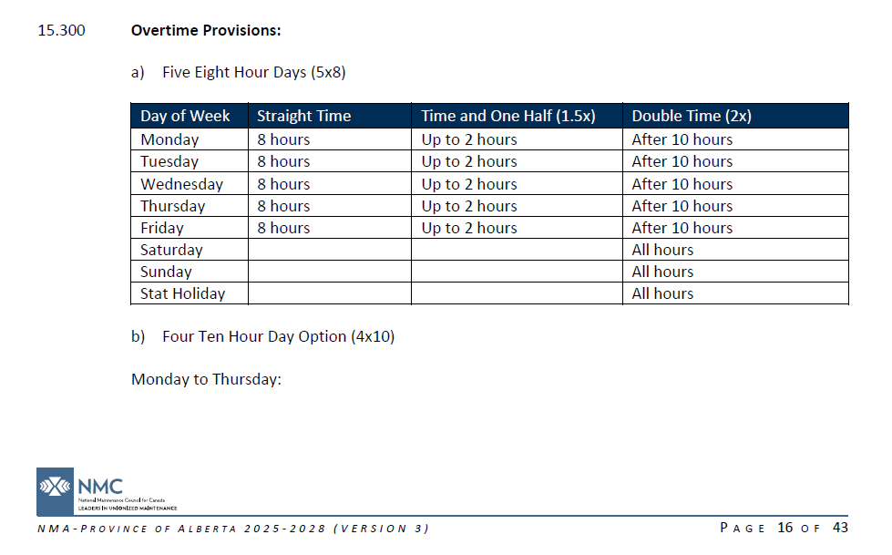
// drop this into a JSON linter for easier reading
{
"id": "<GUID>",
"name": "Overtime Provisions, 5x8 Work Schedule (NMA AB 2025-2028)",
"status": "active",
"created_at": "2025-09-15T00:00:00Z",
"updated_at": null,
"effective_start": "2025-01-01",
"effective_end": "2025-12-31",
"summary": "Employees on a 5x8 schedule: 8 hours straight time; up to 2 hours at 1.5x; after 10 hours at 2x. All hours on Saturday, Sunday, and Statutory Holidays are at 2x.",
"tags": [
"earnings",
"overtime",
"daily"
],
"subjects": [
{
"kind": "employee",
"employment_type": "union"
}
],
"relationships": [],
"context": {
"jurisdiction": "CA-AB",
"work_schedule": "5x8",
"holiday_calendar_ref": "NMA_AB/v2025/HOLIDAY_CAL"
},
"facts": {
"shift_date": "date",
"hours_worked_in_shift": "number"
},
"trigger": {
"==": [
{
"var": "context.work_schedule"
},
"5x8"
]
},
"obligations": [
{
"kind": "rate_schedule",
"basis": {
"var": "facts.hours_worked_in_shift"
},
"bands": [
{
"upto": 8,
"rate": "ST",
"when": {
"and": [
{
"not": {
"is_weekend": [
{
"var": "facts.shift_date"
}
]
}
},
{
"not": {
"is_holiday": [
{
"var": "facts.shift_date"
},
{
"var": "context.holiday_calendar_ref"
}
]
}
}
]
}
},
{
"next": 2,
"rate": "OT",
"when": {
"and": [
{
"not": {
"is_weekend": [
{
"var": "facts.shift_date"
}
]
}
},
{
"not": {
"is_holiday": [
{
"var": "facts.shift_date"
},
{
"var": "context.holiday_calendar_ref"
}
]
}
}
]
}
},
{
"remainder": true,
"rate": "DT"
}
]
}
],
"valuation": {
"tables": [
{
"ref": "NMA_AB/v2025/HOLIDAY_CAL"
}
]
},
"provenance": {
"document": {
"id": "<GUID>",
"title": "National Maintenance Agreement - Province of Alberta 2025-2028",
"short_name": "NMA AB 2025-2028",
"version_label": "Version 3",
"uri": "https://gpmccanada.com/wp-content/uploads/2025/04/NMA-Alberta-Province-Wide-2025-2028-Version-3.pdf"
},
"citation": {
"path": [
"Article 15.300 – Overtime Provisions",
"a) Five Eight Hour Days (5×8)"
],
"pages": [
"16"
]
},
"excerpt": {
"kind": "table",
"format": "json",
"values": [
{
"Day of Week": "Monday",
"Straight Time": "8 hours",
"Time and One Half (1.5x)": "Up to 2 hours",
"Double Time (2x)": "After 10 hours"
},
{
"Day of Week": "Tuesday",
"Straight Time": "8 hours",
"Time and One Half (1.5x)": "Up to 2 hours",
"Double Time (2x)": "After 10 hours"
},
{
"Day of Week": "Wednesday",
"Straight Time": "8 hours",
"Time and One Half (1.5x)": "Up to 2 hours",
"Double Time (2x)": "After 10 hours"
},
{
"Day of Week": "Thursday",
"Straight Time": "8 hours",
"Time and One Half (1.5x)": "Up to 2 hours",
"Double Time (2x)": "After 10 hours"
},
{
"Day of Week": "Friday",
"Straight Time": "8 hours",
"Time and One Half (1.5x)": "Up to 2 hours",
"Double Time (2x)": "After 10 hours"
},
{
"Day of Week": "Saturday",
"Straight Time": "",
"Time and One Half (1.5x)": "",
"Double Time (2x)": "All hours"
},
{
"Day of Week": "Sunday",
"Straight Time": "",
"Time and One Half (1.5x)": "",
"Double Time (2x)": "All hours"
},
{
"Day of Week": "Stat Holiday",
"Straight Time": "",
"Time and One Half (1.5x)": "",
"Double Time (2x)": "All hours"
}
]
}
}
}

NMA-AB, 15.300 (b), Overtime Provisions, 4x10 Mon-Thu Work Schedule
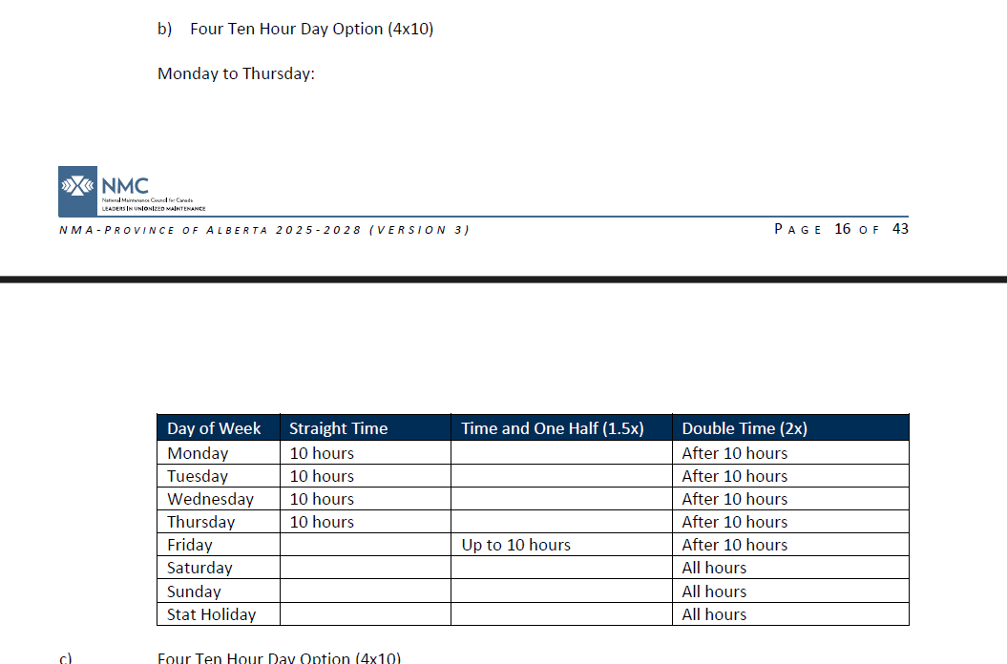
// drop this into a JSON linter for easier reading
{
"id": "<GUID>",
"name": "Overtime Provisions, 4×10 (Mon–Thu) — Daily Ladder",
"status": "active",
"created_at": "2025-09-19T00:00:00Z",
"updated_at": null,
"effective_start": "2025-01-01",
"effective_end": "2028-12-31",
"summary": "Mon–Thu: 10h ST then DT; Fri: up to 10h ST then DT; Sat/Sun/Stat: all DT.",
"tags": [
"earnings",
"overtime",
"daily"
],
"subjects": [
{
"kind": "employee",
"employment_type": "union"
}
],
"relationships": [],
"context": {
"jurisdiction": "CA-AB",
"work_schedule": "4x10_MonThu",
"holiday_calendar_ref": "NMA_AB/v2025/HOLIDAY_CAL"
},
"facts": {
"shift_date": "date",
"hours_worked_in_shift": "number"
},
"trigger": {
"==": [
{
"var": "context.work_schedule"
},
"4x10_MonThu"
]
},
"obligations": [
{
"kind": "rate_schedule",
"basis": {
"var": "facts.hours_worked_in_shift"
},
"bands": [
{
"upto": 10,
"rate": "ST",
"when": {
"and": [
{
"not": {
"is_weekend": [
{
"var": "facts.shift_date"
}
]
}
},
{
"not": {
"is_holiday": [
{
"var": "facts.shift_date"
},
{
"var": "context.holiday_calendar_ref"
}
]
}
},
{
"in": [
{
"day_of_week": {
"var": "facts.shift_date"
}
},
[
"Monday",
"Tuesday",
"Wednesday",
"Thursday"
]
]
}
]
}
},
{
"upto": 10,
"rate": "ST",
"when": {
"==": [
{
"day_of_week": {
"var": "facts.shift_date"
}
},
"Friday"
]
}
},
{
"remainder": true,
"rate": "DT"
}
]
}
],
"valuation": {
"tables": [
{
"ref": "NMA_AB/v2025/HOLIDAY_CAL"
}
]
},
"provenance": {
"document": {
"id": "doc-nmaab-v3",
"title": "National Maintenance Agreement - Province of Alberta 2025-2028",
"short_name": "NMA AB 2025-2028",
"version_label": "Version 3",
"uri": "https://gpmccanada.com/wp-content/uploads/2025/04/NMA-Alberta-Province-Wide-2025-2028-Version-3.pdf"
},
"citation": {
"path": [
"Article 15.300 – Overtime Provisions",
"b) Four Ten Hour Day Option (4×10) — Monday to Thursday"
],
"pages": [
"17"
],
"excerpt": {}
}
}
}

NMA-AB, Appendix D, Overtime Provisions, 9/80 Work Schedule
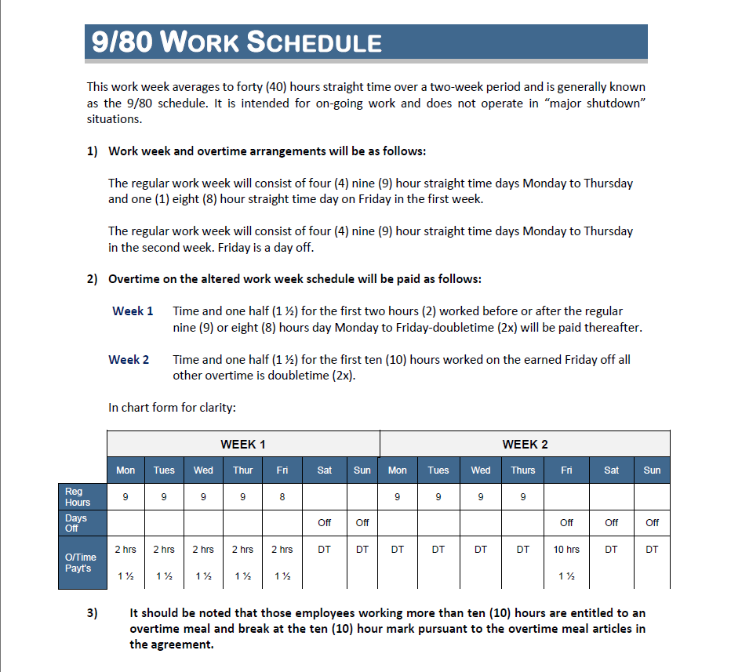
// drop this into a JSON linter for easier reading
{
"id": "NMA-AB/AppD-9x80-Daily",
"name": "Overtime Provisions, 9/80 — Daily Ladder",
"status": "active",
"created_at": "2025-09-19T00:00:00Z",
"updated_at": null,
"effective_start": "2025-01-01",
"effective_end": "2028-12-31",
"summary": "9/80 schedule: Week1 M–Th 9h ST (OT>9) & Fri 8h ST (OT>8); Week2 M–Th 9h ST (OT>9); Earned Friday Off OT: first 10h at 1.5x then DT.",
"tags": [
"earnings",
"overtime",
"daily",
"schedule:9x80"
],
"subjects": [
{
"kind": "employee",
"employment_type": "union"
}
],
"relationships": [],
"context": {
"jurisdiction": "CA-AB",
"work_schedule": "9x80",
"holiday_calendar_ref": "NMA_AB/v2025/HOLIDAY_CAL"
},
"facts": {
"shift_date": "date",
"hours_worked_in_shift": "number",
"schedule_week_number": "integer"
},
"trigger": {
"==": [
{
"var": "context.work_schedule"
},
"9x80"
]
},
"obligations": [
{
"kind": "rate_schedule",
"basis": {
"var": "facts.hours_worked_in_shift"
},
"bands": [
{
"upto": 9,
"rate": "ST",
"when": {
"and": [
{
"in": [
{
"day_of_week": {
"var": "facts.shift_date"
}
},
[
"Monday",
"Tuesday",
"Wednesday",
"Thursday"
]
]
},
{
"==": [
{
"var": "facts.schedule_week_number"
},
1
]
}
]
}
},
{
"upto": 8,
"rate": "ST",
"when": {
"and": [
{
"==": [
{
"var": "facts.schedule_week_number"
},
1
]
},
{
"==": [
{
"day_of_week": {
"var": "facts.shift_date"
}
},
"Friday"
]
}
]
}
},
{
"upto": 9,
"rate": "ST",
"when": {
"and": [
{
"in": [
{
"day_of_week": {
"var": "facts.shift_date"
}
},
[
"Monday",
"Tuesday",
"Wednesday",
"Thursday"
]
]
},
{
"==": [
{
"var": "facts.schedule_week_number"
},
2
]
}
]
}
},
{
"upto": 10,
"rate": "OT",
"when": {
"and": [
{
"==": [
{
"var": "facts.schedule_week_number"
},
2
]
},
{
"==": [
{
"day_of_week": {
"var": "facts.shift_date"
}
},
"Friday"
]
}
]
}
},
{
"remainder": true,
"rate": "DT"
}
]
}
],
"valuation": {
"tables": [
{
"ref": "NMA_AB/v2025/HOLIDAY_CAL"
}
]
},
"provenance": {
"document": {
"id": "doc-nmaab-v3",
"title": "National Maintenance Agreement - Province of Alberta 2025-2028",
"short_name": "NMA AB 2025-2028",
"version_label": "Version 3",
"uri": "https://gpmccanada.com/wp-content/uploads/2025/04/NMA-Alberta-Province-Wide-2025-2028-Version-3.pdf"
},
"citation": {
"path": [
"Appendix D – Approved Work Week Alterations",
"9/80 Work Schedule"
],
"pages": [
"33"
]
},
"excerpt": {}
}
}

High Complexity Rules

NMA-AB, 15.600, Overtime Meal Breaks & Meals
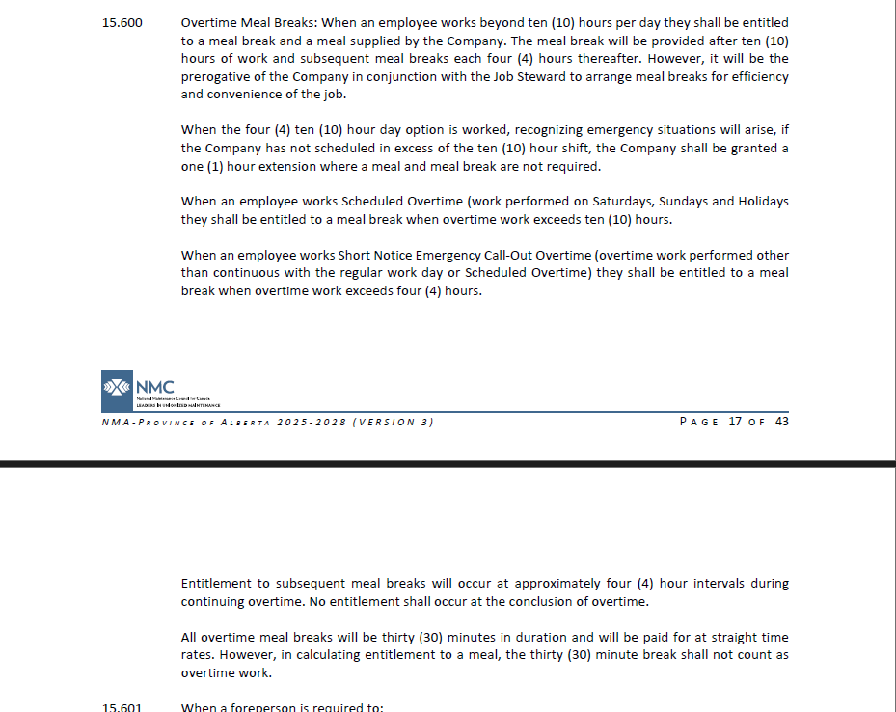
// drop this into a JSON linter for easier reading
{
"schema_version": "1.0.0",
"id": "<GUID>",
"name": " Overtime Meal Breaks & Meal",
"summary": "Meal + 30-min paid meal break once threshold reached, then every 4h while OT continues; no entitlement at conclusion of OT.",
"status": "active",
"created_at": "2025-09-19T00:00:00Z",
"updated_at": null,
"effective_start": "2025-01-01",
"effective_end": "2028-12-31",
"subjects": [
{
"kind": "employee"
}
],
"context": {
"jurisdiction": "CA-AB"
},
"facts": {
"hours_worked_in_shift": "number",
"overtime_hours_today": "number",
"is_scheduled_overtime_day": "boolean",
"is_short_notice_callout": "boolean",
"is_four_ten_option": "boolean",
"scheduled_beyond_ten": "boolean",
"continues_overtime": "boolean",
"paid_meal_break_30m_count": "number",
"meals_provided_count": "number"
},
"trigger": {
"when": {
"or": [
{
"and": [
{
"var": "facts.is_short_notice_callout"
},
{
">": [
{
"var": "facts.overtime_hours_today"
},
4
]
}
]
},
{
"and": [
{
"var": "facts.is_scheduled_overtime_day"
},
{
">": [
{
"var": "facts.overtime_hours_today"
},
10
]
}
]
},
{
"and": [
{
"not": {
"var": "facts.is_scheduled_overtime_day"
}
},
{
"not": {
"var": "facts.is_short_notice_callout"
}
},
{
">": [
{
"var": "facts.hours_worked_in_shift"
},
10
]
},
{
"or": [
{
"not": {
"var": "facts.is_four_ten_option"
}
},
{
"var": "facts.scheduled_beyond_ten"
},
{
">": [
{
"var": "facts.hours_worked_in_shift"
},
11
]
}
]
}
]
}
]
},
"recurs": [
{
"frequency": "hourly",
"interval": 4,
"count": {
"floor": {
"/": [
{
"max": [
0,
{
"-": [
{
"var": "facts.hours_worked_in_shift"
},
10
]
}
]
},
4
]
}
}
}
]
},
"obligations": [
{
"kind": "break",
"duration_minutes": 30,
"paid": true,
"rate": "ST",
"counts_toward_overtime": false,
"provision_tag": "meal.break30",
"fulfilled_count": "facts.paid_meal_break_30m_count"
},
{
"kind": "meal",
"mode": "company_provided",
"provision_tag": "meal.provided",
"fulfillment_fact": "facts.meals_provided_count"
}
],
"operations": [],
"provenance": {
"document": {
"id": "<GUID>",
"title": "National Maintenance Agreement - Province of Alberta 2025-2028",
"short_name": "NMA AB 2025-2028",
"version_label": "Version 3",
"uri": "https://gpmccanada.com/wp-content/uploads/2025/04/NMA-Alberta-Province-Wide-2025-2028-Version-3.pdf"
},
"citation": {
"path": [
"Article 15.600 – Overtime Meal Breaks"
],
"pages": [
"17",
"18"
]
}
}
}

NMA-AB, 15.601, Overtime Meas Breaks & Meals (Foreperson)
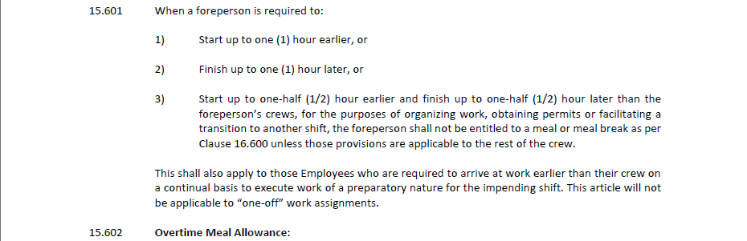
Need to redo this example
…
"provenance": {
"document": {
"id": "doc-nmaab-v3",
"title": "National Maintenance Agreement - Province of Alberta 2025-2028",
"short_name": "NMA AB 2025-2028",
"version_label": "Version 3",
"uri": "https://gpmccanada.com/wp-content/uploads/2025/04/NMA-Alberta-Province-Wide-2025-2028-Version-3.pdf"
},
"citation": {
"path": [
"Article 15.601 – Foreperson/Crew Variance"
],
"pages": [
"18"
]
}
}
}

NMA-AB, 15.602, Overtime Meal Allowance
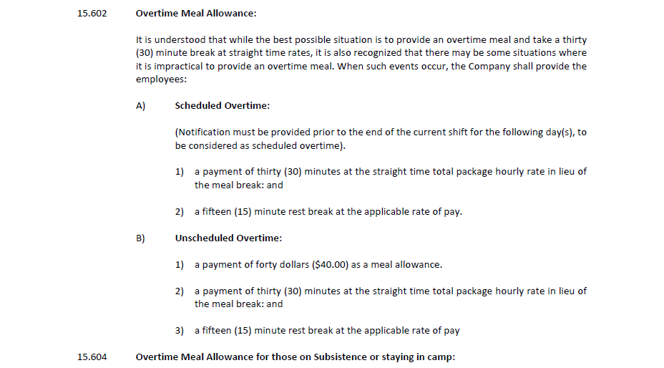
// drop this into a JSON linter for easier reading
{
"schema_version": "1.0.0",
"id": "<GUID>",
"name": " Overtime Meal Allowance (In-Lieu of Meal & Break)",
"summary": "If providing meals is impractical: Scheduled OT → 30m at ST in lieu + 15m rest at applicable rate; Unscheduled OT → same plus $40 allowance. Applies per owed-but-unprovided meal.",
"status": "active",
"created_at": "2025-09-19T00:00:00Z",
"updated_at": null,
"effective_start": "2025-01-01",
"effective_end": "2028-12-31",
"tags": [
"overtime",
"meal",
"meal allowance"
],
"subjects": [
{
"kind": "employee"
}
],
"context": {
"jurisdiction": "CA-AB"
},
"facts": {
"meals_received_count": "number",
"is_scheduled_overtime_day": "boolean"
},
"trigger": true,
"obligations": [],
"operations": [
{
"op": "substitute",
"select": {
"provision_tag": "meal.provided",
"facts.is_scheduled_overtime_day": true
},
"scope": "provision_group",
"replacements": "per_missing",
"obligations": [
{
"kind": "break",
"duration_minutes": 30,
"paid": true,
"rate": "ST",
"provision_tag": "inlieu.break30"
},
{
"kind": "break",
"duration_minutes": 15,
"paid": true,
"rate": "APPLICABLE_OT",
"provision_tag": "inlieu.rest15"
}
]
},
{
"op": "substitute",
"select": {
"provision_tag": "meal.provided",
"facts.is_short_notice_callout": true
},
"scope": "provision_group",
"replacements": "per_missing",
"obligations": [
{
"kind": "allowance",
"amount": 40,
"currency": "CAD",
"provision_tag": "allowance.$40"
},
{
"kind": "break",
"duration_minutes": 30,
"paid": true,
"rate": "ST",
"provision_tag": "inlieu.break30"
},
{
"kind": "break",
"duration_minutes": 15,
"paid": true,
"rate": "APPLICABLE_OT",
"provision_tag": "inlieu.rest15"
}
]
}
],
"provenance": {
"document": {
"id": "doc-nmaab-v3",
"title": "National Maintenance Agreement - Province of Alberta 2025-2028",
"short_name": "NMA AB 2025-2028",
"version_label": "Version 3",
"uri": "https://gpmccanada.com/wp-content/uploads/2025/04/NMA-Alberta-Province-Wide-2025-2028-Version-3.pdf"
},
"citation": {
"path": [
"Article 15.602 – Overtime Meal Allowance"
],
"pages": [
"18"
]
}
}
}

NMA-AB, 15.604, Overtime Meal Allowance (Subsistence & Camp)
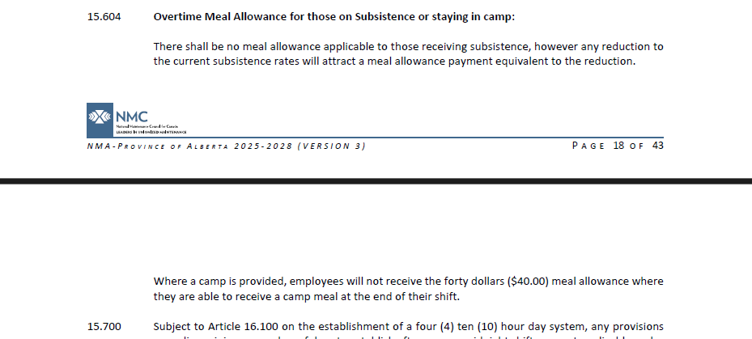
// drop this into a JSON linter for easier reading
{
"schema_version": "1.0.0",
"id": "<GUID>",
"name": "Overtime Meal Allowance Reduction (Camp or Subsistence)",
"summary": "Prevents duplication of overtime meal allowance when meals are already covered by camp provisions or a subsistence allowance. Removes or reduces the $40 allowance accordingly.",
"status": "active",
"created_at": "2025-09-19T00:00:00Z",
"updated_at": null,
"effective_start": "2025-01-01",
"effective_end": "2028-12-31",
"tags": [
"overtime",
"meal allowance",
"subsistence",
"camp"
],
"subjects": [
{
"kind": "employee"
}
],
"context": {
"jurisdiction": "CA-AB"
},
"facts": {
"is_in_camp": "boolean",
"subsistence_reduction_amount": "number"
},
"trigger": true,
"obligations": [],
"operations": [
{
"op": "remove",
"select": {
"provision_tag": "allowance.$40",
"facts.is_in_camp": true
},
"scope": "provision_item"
},
{
"op": "top_up",
"select": {
"provision_tag": "allowance.$40",
"facts.subsistence_reduction_amount": {
"gt": 0
}
},
"scope": "provision_item",
"to": {
"min": [
40,
{
"var": "facts.subsistence_reduction_amount"
}
]
},
"obligations": [
{
"kind": "allowance",
"currency": "CAD",
"provision_tag": "allowance.topup.subsistence",
"amount": {
"delta": "amount"
}
}
]
}
],
"provenance": {
"document": {
"id": "<GUID>",
"title": "National Maintenance Agreement - Province of Alberta 2025-2028",
"short_name": "NMA AB 2025-2028",
"version_label": "Version 3",
"uri": "https://gpmccanada.com/wp-content/uploads/2025/04/NMA-Alberta-Province-Wide-2025-2028-Version-3.pdf"
},
"citation": {
"path": [
"Article 15.604 – Meal Allowance Reductions"
],
"pages": [
"19"
]
}
}
}

Scaling FieldVu Rule Validation
The rule card design supports validation at many levels — from one line to entire spans of history — without changing structure. What changes is the size of the dataset and the grain of aggregation.

Multiple labour lines on a crew sheet
- FieldVu applies shared Applicability anchors once (jurisdiction, customer, site, job, agreement).
- Candidate rules are fetched once for that crew sheet.
- Each line (with its own worker, craft, shift, etc.) is then validated individually against that same rule set.
- This prevents duplicate lookups and ensures consistency across all lines on the sheet.

Multiple crew sheets for the same day
- At the daily level, FieldVu collects all labour lines from all sheets for that date.
- Daily totals are computed once (e.g., hours per worker/day, site/day).
- Rules that rely on daily aggregates (like daily overtime thresholds) reuse these totals, instead of recalculating them per line.
- Each line is still validated individually, but now against both its own data and the day-level aggregates.

Multiple days (weekly validation before invoicing)
- FieldVu groups labour lines by worker/week (or by other configured intervals).
- Weekly totals are computed once (e.g., hours per worker/week, weekly allowances).
- Rules that apply weekly (e.g., overtime after 40 hours in a week, weekly travel caps) validate against these aggregates.
- This makes it possible to confirm compliance before invoices are generated for the entire week.

Historical reporting and auditing
- The same mechanics apply across larger spans (days, weeks, months, or arbitrary ranges).
- Effective dates ensure each labour line is validated against the rules that were in force at the time.
- FieldVu can batch validation, reuse aggregates (daily, weekly, monthly), and guarantee point-in-time accuracy for audits. Or perhaps this is not FieldVu but separate reporting solution.
- Either way, this enables confidence in long-term reporting, back-checks, and compliance investigations.
The important point: the rule card itself does not change, and the runtime process flow (Applicability → Priority → Criteria) does not change in principle. What changes at larger scales is how FieldVu groups lines together and precomputes totals so they can be reused efficiently. Techniques such as precomputing, parallelizing, or distributing calculations may be applied for speed — but the core rule card design remains the same.

Open Issues

What degree of rules do we need to extract from the source documents?
Chris H to fill in. Has to do with if we don’t pull all, then we leave some, then we run the risk of missing something, then user loses trust in solution. Better would be to enforce that we pull all billable/payable rules, store them in the rules knowledve base, and FieldVu is able to use the knoes today that it knows how to, and grow into using the others in future that it doesn’tk now how to yet.

How will we indicate to FieldVu which rules in the rules knowlesve base it knows how to apply vs doesn’t have capabiltiesi for?
e.g. overtime rules that depemend on “work schedule”, overtime calculation that depends on whether worker was “called out in between sfhits”, etc.

Do we need to support some other types than “text” in rule excerpt? (e.g. table)
Feels like we do. Why? The intent of the provenance citation excerpt is to display to the end user the actual content, verbatim, from which the rule was extracted. If we do support tables and other formats, the format of that/those is still TBD.

Do we need capture on the rule card the parties the agreement pertains to?
e.g. signing parties to the agreement (e.g. EdEx, Customer, Union), covered parties to the agreement (e.g. employees, workers)
Don’t know yet. These might be addressed by other fields on the rule card. TBD.

How will FieldVu know which overtime rules to apply if it has no concept of work schedule?
In the absence of FieldVu knowing what “work schedule the worker is on (e.g. 5x8, 4x10 Monday, …) it won’t be able to pull the correct overtime rule and therefore know how to properly evaluate the overtime and doublie time. So, until FieldVu does have that awareness, it will have to assume workers are on the standard work week schedule of 5x8.

Overtime Work Schedule rules are interesting. They actually apply to work that entire day, not single Crew Sheet. How will FieldVu know/handle this?
When you’re in FieldVu, you obviously want to know if worker’s time is entered into the correct buckets ST, OT, DT. But looking just at that crew sheet is not enough to answer that, because the overtime rules are based on the total hours that worker worked that day, and so if their hours are recorded across multiple crew sheets then you need to factor that in when validating overtime rules when looking at any one of those individual crew sheets.

Closed Issues

Vocabulary
Scheduled Overtime = work that was scheduled in advance to be performed on Saturday, Sunday, or Satutory Holiday - this taken directly from NMA AB
Unscheduled Overtime = overtime work performed continuous with the regular work day – this inferred from text taken direct from NMA AB
Short Notice Emergency Call-Out Overtime “(overtime work performed other than continuous with the regular work day or Scheduled Overtime)” – this taken directly from NMA AB

FieldVu Crew Sheet & Fields We Have / Don’t Have Today Relative to Contract/Agreement Rules

This is not a final list but reflective of what’s known as at Sep 17, 2025

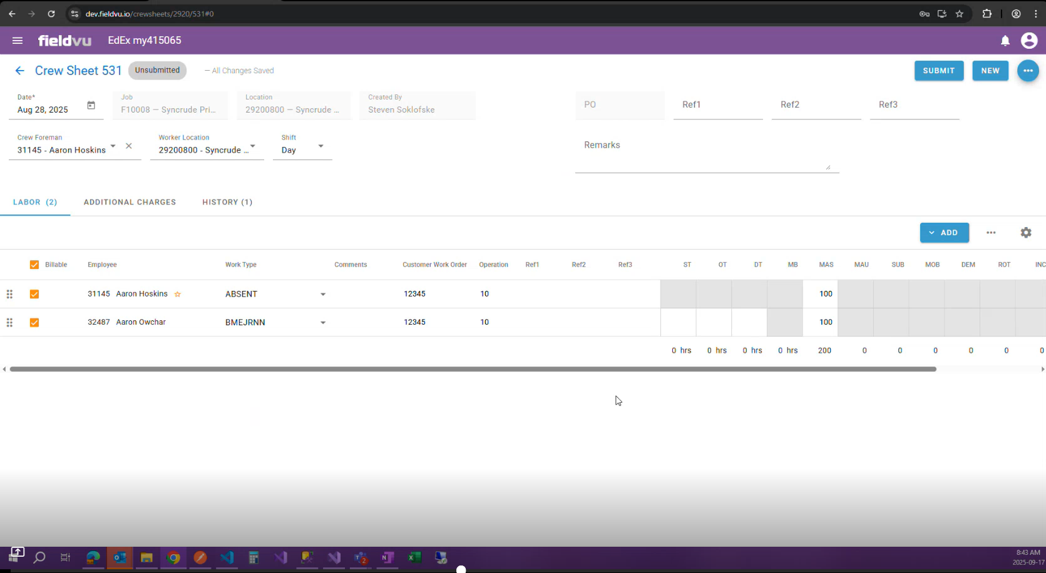

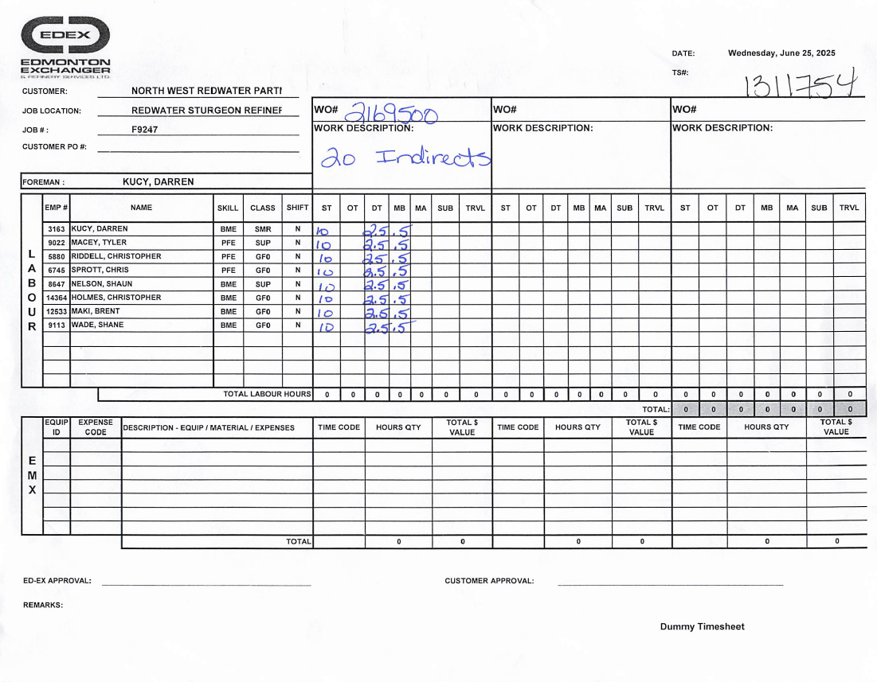

Fields that FieldVu Crew Sheet Has or Can Derive
(only included labour related line-level fields for now)
✅Customer
✅Job Location / Location / Site
✅Job # / Job
❌Job Camp Provided
❌Job Subsistence Provided
❌Scheduled Overtime vs Unscheduled Overtime
❌Call Out / Call Out Between Shifts / Emergency Call Out
✅Customer PO #
✅Date (i.e. Work Date)
✅Document Number / TS # / Crew Sheet Number
✅Document Status (e.g. Unsubmitted)
✅Foreman / Crew Foreman
✅Crew Sheet Work Description / Remarks
✅Employee ID / Emp # / Worker ID
✅Employee Name / Name / Worker Name
❌Worker Work Schedule (e.g. 5x8, 4x10 Mon, 4x10 Tue, …)
❌Worker Work Start Time
❌Worker Work Finish Time
❌Worker Work Finish Time
❔Worker Unionized vs Non-Unionized
❔Worker Union Membership
✅Worker Craft / Skill (it’s encoded in Work Type)
✅Worker Class / Class (it’s encoded in Work Type)
✅Work Shift / Shift (it’s encoded in Work Type)
❌Worker Reported for Duty but No Work Today
❌Was Pre-Required Orientation or Training to Arriving on Site
❌Was Customer or Site Required Orientation or Training
✅Worker Work Description / Comments
✅ Operation ID / Work Activity
✅Standard Time Hours / ST
✅Overtime Hours / OT
✅Double Time Hours / DT
✅Meal Break Hours / MB
✅Meal Allowance Scheduled / MAS
✅Meal Allowance Unscheduled / MAU
✅Subsistence Pay / SUB / LOA / Living Out Allowance / Per Diem
✅Mobilization / MOB (this is TRVL on dummy/paper Crew Sheet)
✅Demobilization / DEM (this is TRVL on dummy/paper Crew Sheet)
❌Worker Travel is Initial or Terminal
❌Job Customer Provides Transportation
❌Job Radius Km for Travel Reimbursement
✅Rotation Pay / ROT
✅Incentive Pay / INC
✅Bonus Pay / BON
✅Worker Total Hours
❌Company Decision Not To Provide Meals Owed to Workers
❌Worker Received Owed Meals Quantity
❌Worker Paid Rest Break Hours
❌Worker Subsistence Reduction Amount

